Database lab 6 Task
Q1. Solve the Queries below using subquery
- Find employees who were hired after the latest hired employee from department 60.
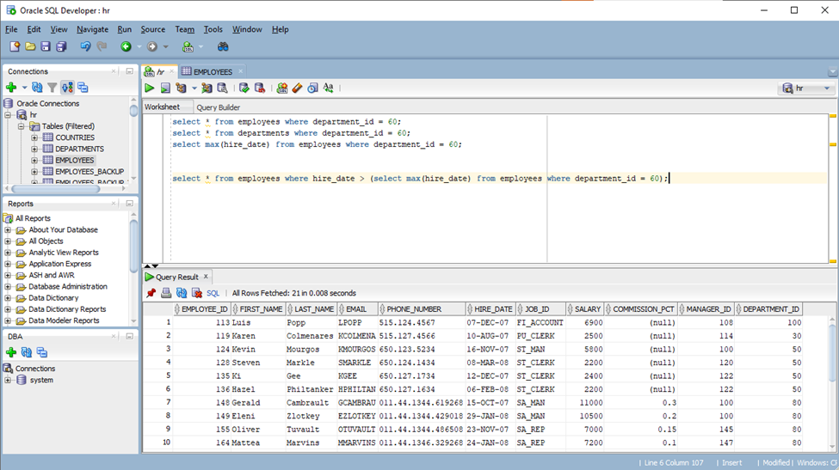
- Display employees earning more than the average salary of Sales Representatives.
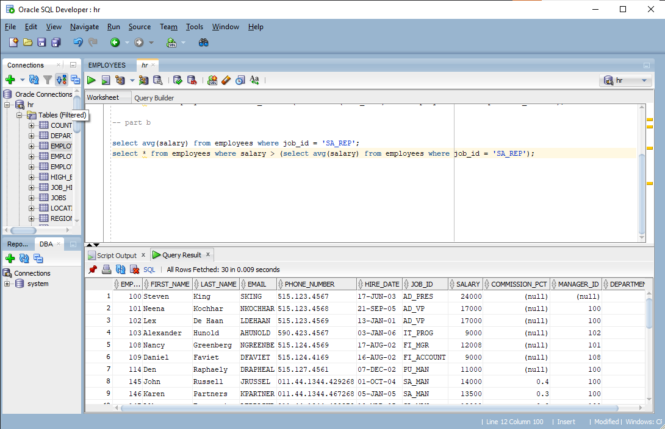
- Employees Working in the Same Department as Employee 103. Without using JOIN, use subquery.
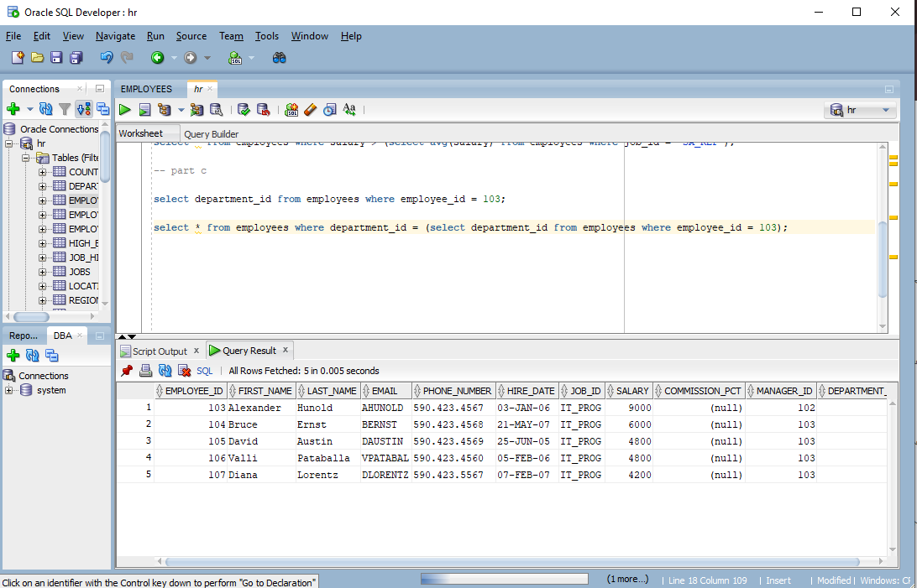
- Jobs Having Higher Min Salary Than Company Average Salary. Display job_title and min_salary where min_salary is greater than average salary of all employees.
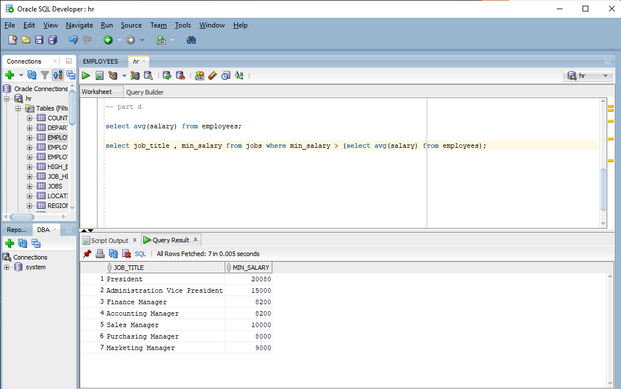
- Employees Whose Salary Is Equal to Minimum Salary of Any Department. Use subquery to compare.
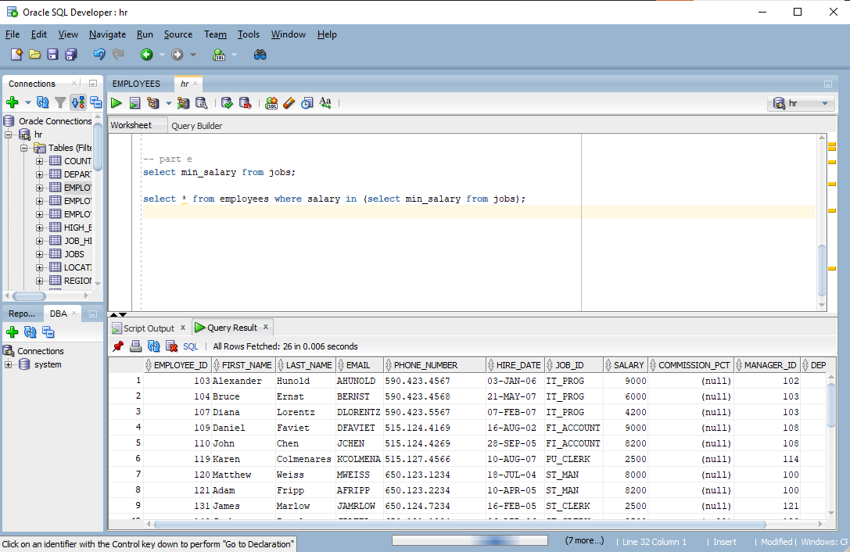

Q2.
- Employees Who Report to Same Manager as Employee 101
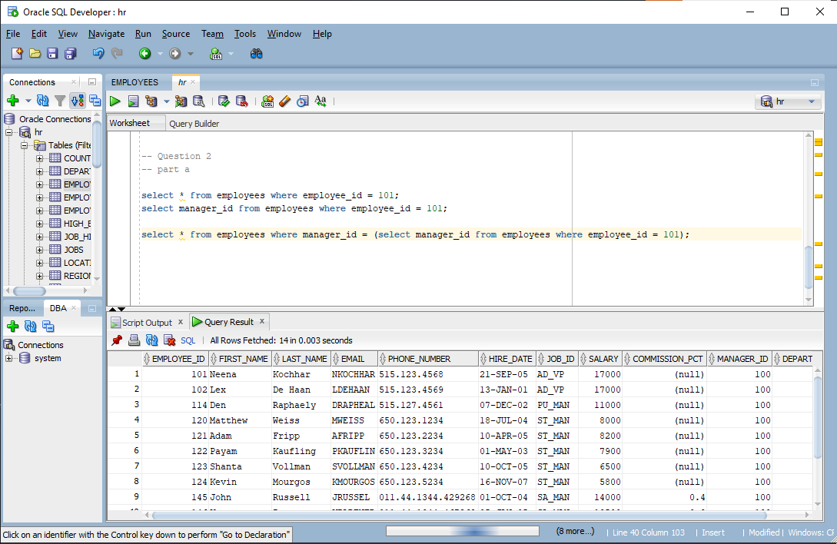
- Employees Working in Departments That Have More Than One Manager
(Hint: Use correlated subquery)
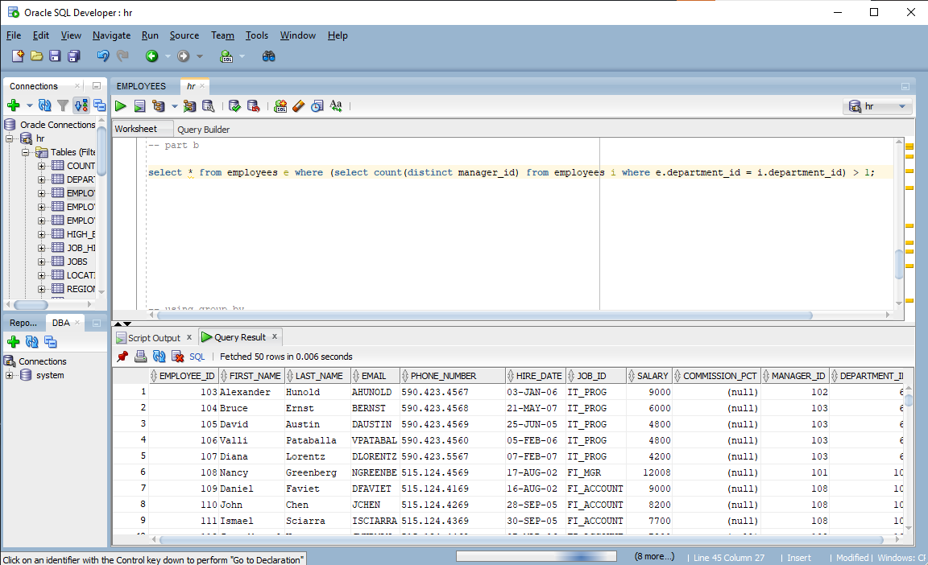
- Departments Where Average Salary Is Greater Than Average Salary of Department 90
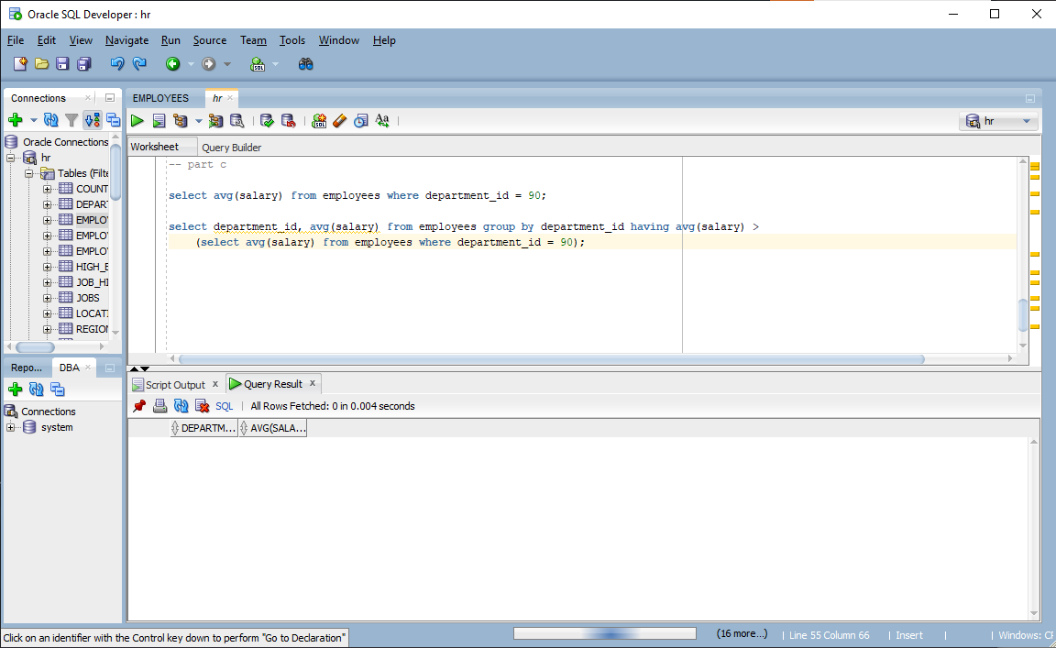
- Employees Whose Salary Is Greater Than Median Salary
(You must calculate the median using subquery logic.)
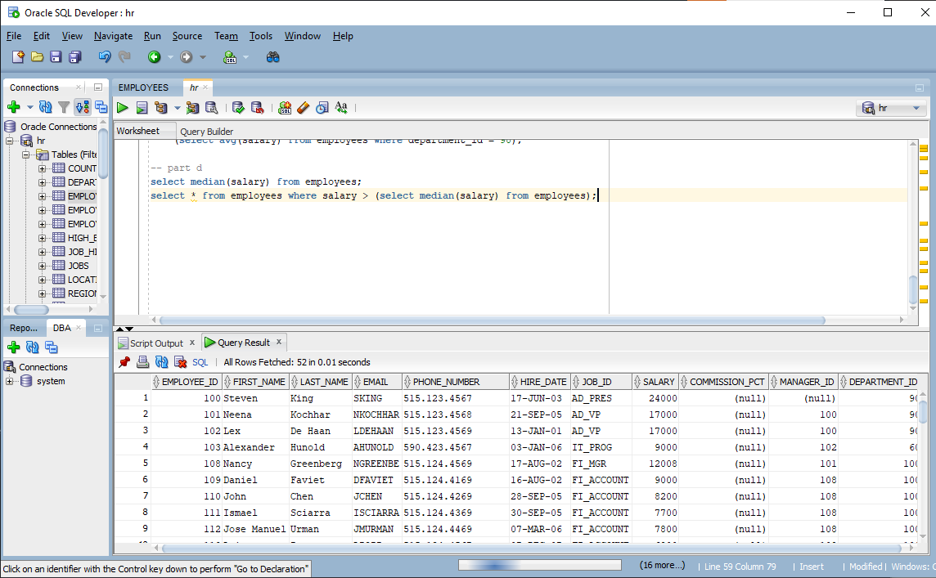
- Employees Whose Commission Is Higher Than Average Commission
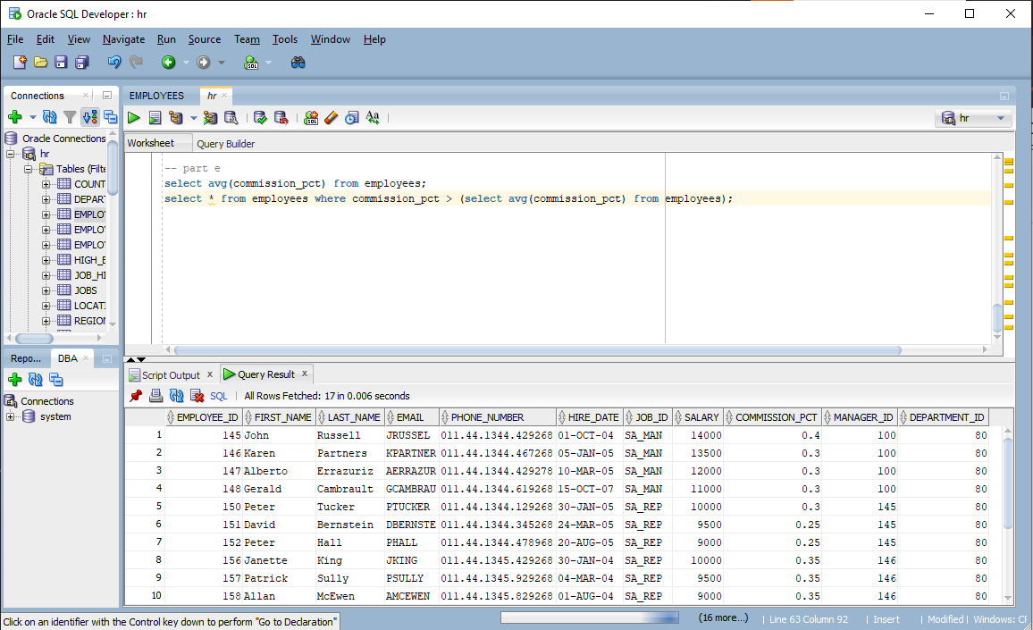
- Employees Working in Departments Located in Same City as 'Marketing' Department
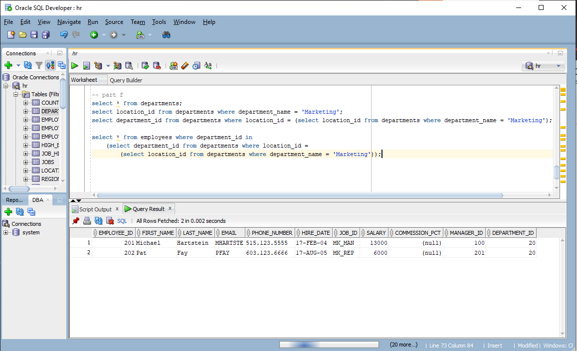
- Employees Whose Salary Is Not Equal To Any Salary in Department 50
(Use NOT IN carefully)
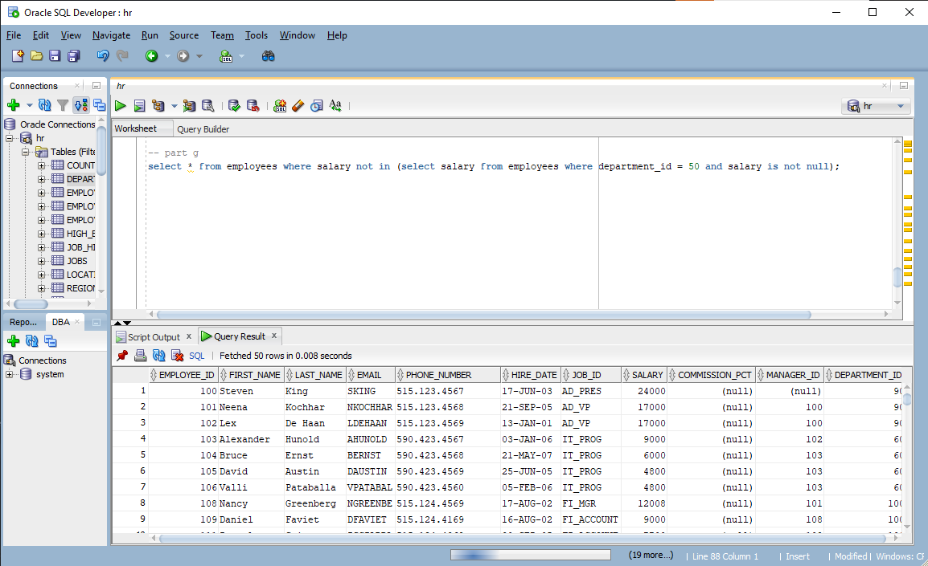
- Employees Whose Salary Is Between Average Salary of Dept 10 and Dept 20
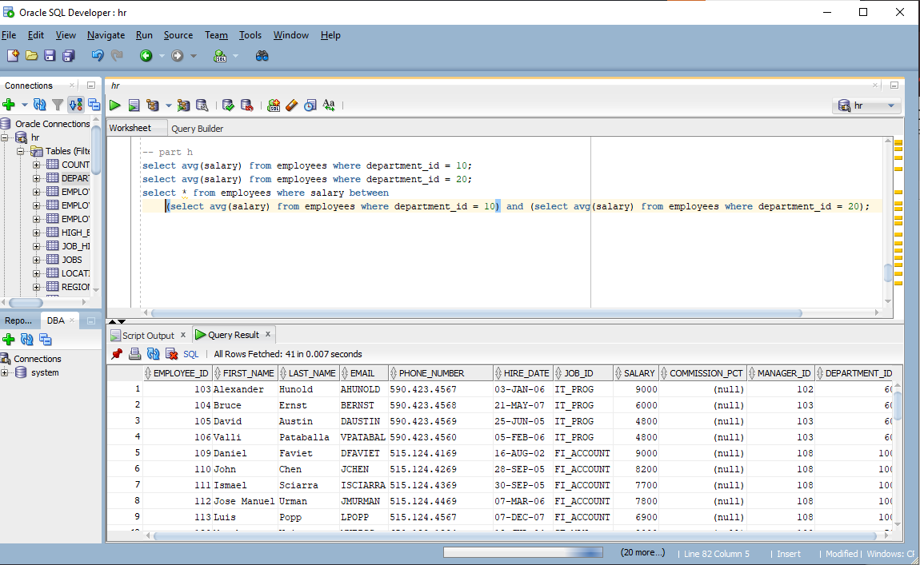
- Employees Who Have Changed Jobs (Exist in Job_History Table)
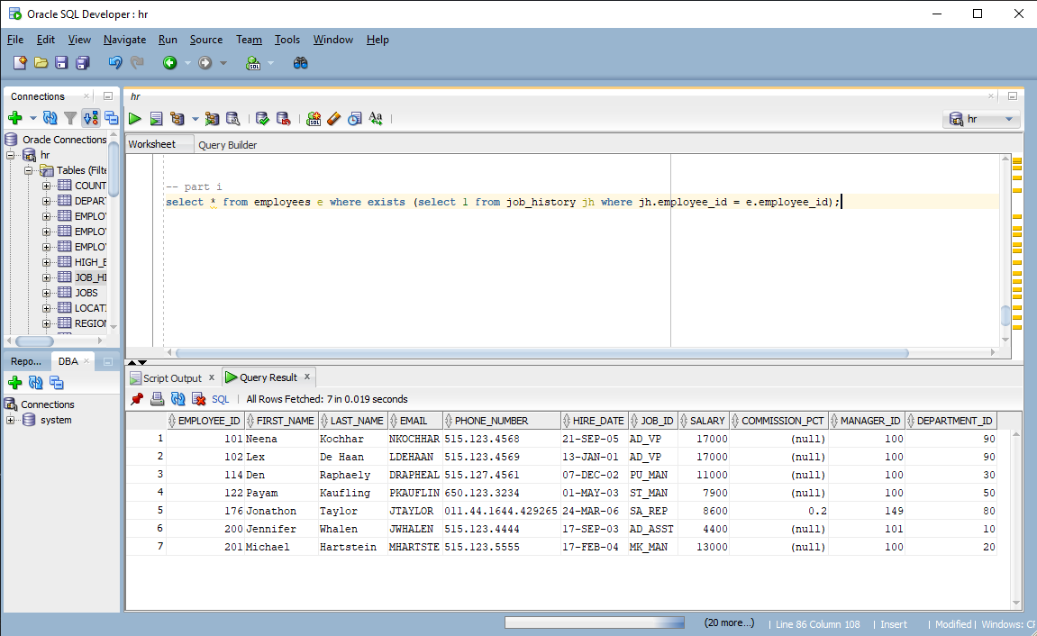

Q3. Board Audit Report
Board requires employees who:
- Work in departments where average salary > company average
- Have salary greater than their department average
- Have worked more than 10 years
- Have no job history record
- Are not managers
write using multiple nested subqueries + EXISTS / NOT EXISTS.
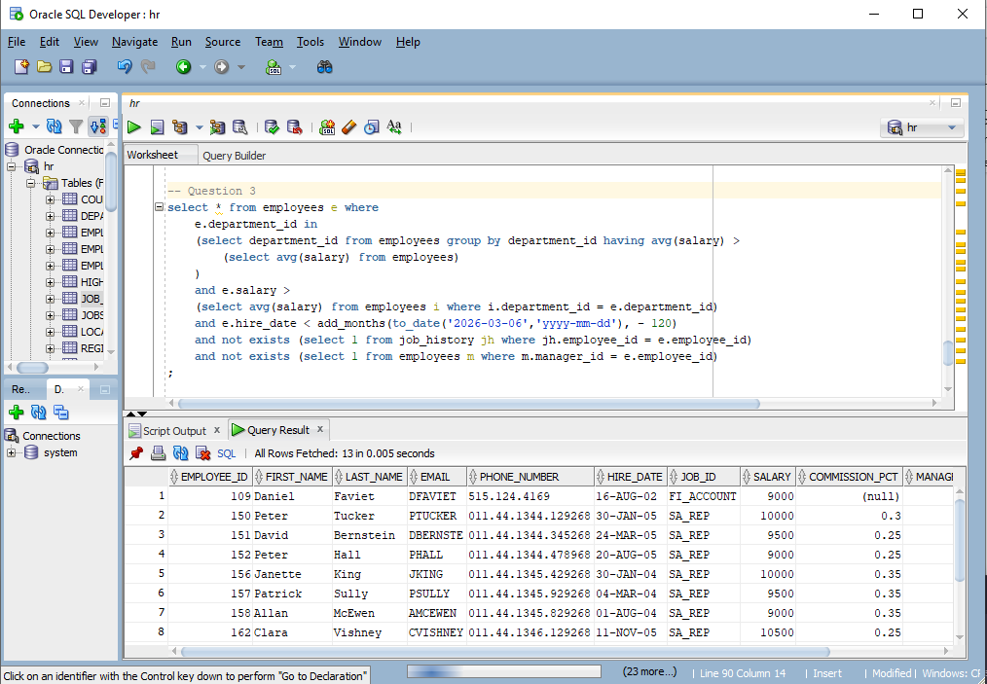

Q4. Display departments where there exists at least one employee earning more than company average AND at least one earning below company average.
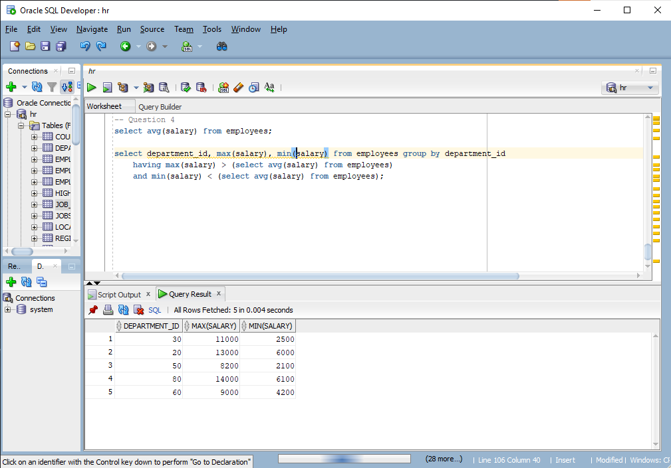

Q5. Management wants employees who:
- Belong to departments where total salary expense is greater than the highest salary in the company
- Earn less than department maximum but greater than department average
- Are NOT managers
- Have salary greater than ALL employees in department 30
- Work in departments located in cities where more than one department exists
Use:
- ALL operator
- Correlated subquery
- Inline view
- EXISTS
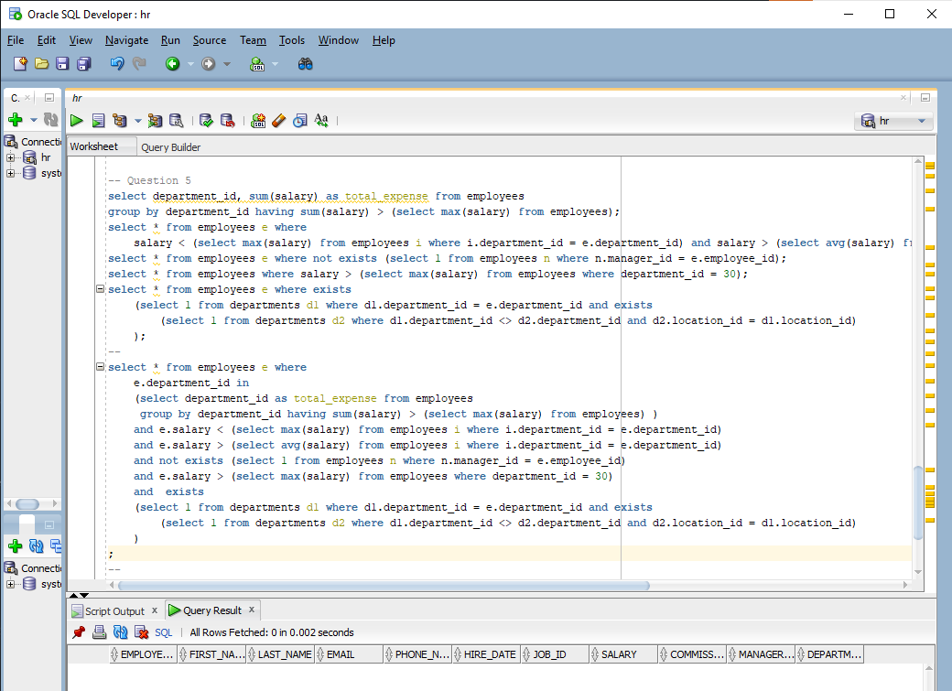

Q6. Board is checking unstable departments. Display employees who:
- Work in departments where salary gap (MAX - MIN) is greater than company average salary
- Earn more than department median salary
- Are not the highest paid in their department
- Have never changed jobs (not in job_history)
- Work in departments where every employee earns more than 4000
Use:
- ALL operator
Nested aggregate subqueries
Correlated logic
NOT EXISTS
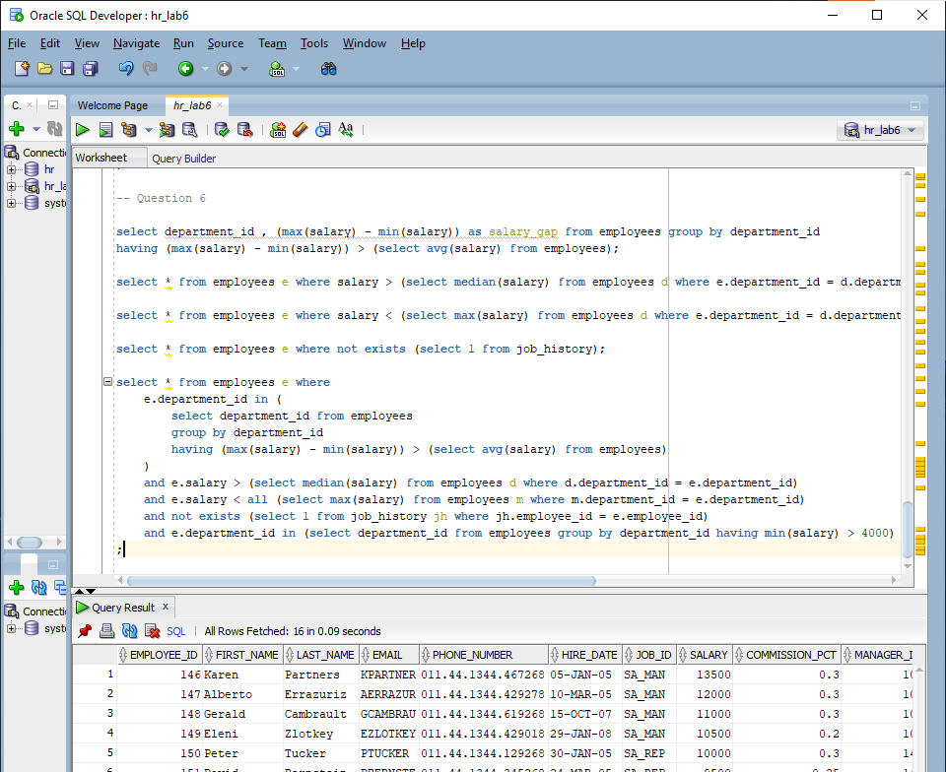

Q7. The company wants to shortlist “elite” employees who:
- Work in departments whose average salary is greater than company average
- Earn more than department average
- Earn less than the highest salary in company but more than ALL employees in department 20
- Have worked more years than their manager
- Belong to departments where there exists at least one employee hired after 2020
- Are not managers
- Do not exist in job_history
Write a single complex SQL query
